DEPARTMENT OF INDUSTRIAL PSYCHOLOGY

FULL-TIME HONOURS TIMETABLE

HONS BCOMM (HRM) & HONS BCOMM (INDUSTRIAL PSYCHOLOGY)

SECOND SEMESTER 2017

TIME | MONDAY | TUESDAY | WEDNESDAY | THURSDAY | FRIDAY
08:30 –  10:30 | Psychometrics: Measurement  Theory, Test Construction &  Decision-making  [Industrial Psych]  Prof C Theron | SPSS & LISREL - Practical  [Industrial Psych]  Room: E02.1 & E02.2  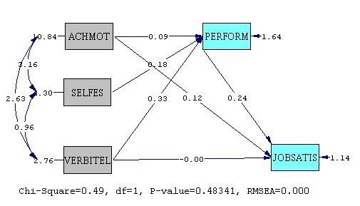  [08H00-10H00]  Prof C Theron | Strategic Human Resource  Management II  [All]  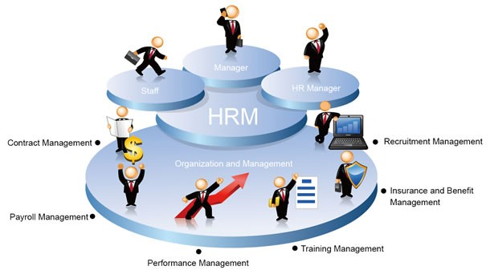  Mr F van der Bank | Workshops / group work / activities as scheduled  [  ]  All | Workshops / group work / activities as scheduled  [  ]  All
11:00 –  13:00 | Employment Relations & Labour  Legislation  [Industrial Psych]  Mr G Cillié | Industrial Relations: Theory &  Practices (Processes)  [HRM]  Mr G Cillié | Organisational Psychology:  Contemporary Challenges  [All]  Dr B Boonzaier
14:00-
16:00

